Application note 012b TVM

This application note demonstrates C47/R47 TVM (Time Value of Money) functionality through 23 worked examples.

Contents
Learning outcomes: 1
Section 2: 11 problems from a worked out financial calculator tutorial. 1
Section 3: 12 numerical test cases from the calculator community as downloadable RPN programs. 1
Introduction 2
List of worked out application note examples: 2
Section 1: Reference to HP TVM calculators: 3
Section 2: Worked out tutorial Drs. Baker & Lin 4
Section 3: From Swissmicros Forum, dm319’s problem set 9

Learning outcomes:

Section 2: 11 problems from a worked out financial calculator tutorial.

The learning outcomes of Section 2 focus on TVM fundamentals: understanding how the five core variables interact, setting payment and compounding periods correctly, and recognizing when to use Begin versus End mode.

Examples 3A/3B/3C demonstrate that different problem approaches yield the same answer.
Example 5 teaches period conversion (annual to bi-weekly).
Examples 6 and 7 show how adding constraints changes the calculation.
Example 11 covers nominal to effective interest rate conversions.

Section 3: 12 numerical test cases from the calculator community as downloadable RPN programs.

The learning outcomes of Section 3 shift to understanding the TVM functions by programming same: structuring complete TVM programs, organizing multi-step calculations, and controlling solver behaviour.

Problems demonstrate straightforward setup and solving and progress to teach program sequencing when multiple TVM operations are required. Problems 5/5b and 6/6b specifically teach solver bias control, showing how to obtain different valid solutions by setting initial guesses.

All programs are available at 47calc.com, on the appnote section for practice and adaptation.

Introduction

The C47 TVM implementation follows HP financial calculator conventions but requires explicit setup of payment and compounding periods. The five core TVM registers are n (number of periods), I/a (annual interest rate as percentage), PV (present value), PMT (payment per period), and FV (future value). Special settings control pp/a (payment periods per year), cp/a (compounding periods per year), and Begin/End mode (when interest applies). Functions EFF/a and DEFF/a convert between nominal and effective annual rates.

List of worked out application note examples:

Section 2 demonstrates typical financial calculations using problems from the Baker & Lin tutorial:

- Example 1: Calculate FV given initial investment and time horizon
- Example 2: Calculate PV of a future amount
- Example 3: Compare lottery options (lump sum vs annuity stream)
- Example 3A: Same comparison using BEGIN mode
- Example 3B/C: Alternative approach comparing future values instead of present values
- Example 4: Calculate required annual savings to reach investment goal
- Example 5: Calculate bi-weekly savings (26 periods per year)
- Example 6: Determine required rate of return given savings capacity
- Example 7: Required return with existing capital and ongoing contributions
- Example 11: Convert nominal to effective interest rates for quarterly and daily compounding

Section 3 tackles numerical edge cases from dm319 (Duncan's) calculator test suite, implemented as RPN:

- Problem 1: Monthly mortgage payment over 38 years
- Problem 1b: Reverse calculation verifying interest rate
- Problem 2: Payment differential from rate change, then PV calculation
- Problem 3: Kahan's extreme test (60×60×24×365 periods)
- Problem 4: Zero interest rate round-trip (exposes floating point precision limits)
- Problem 5: Multiple solution test (default solver finds first root at 14.44%)
- Problem 5b: Biased solver finds second root at 53.17%
- Problem 6: Multiple solution test (default finds -36.89%)
- Problem 6b: Biased solver finds second root at 58.46%
- Problem 7: Near-zero FV with fractional payments
- Problem 8: Small interest rate precision test
- Problem 9: Period calculation in END mode
- Problem 10: Period calculation in BEGIN mode
- Problem 11: Sequential FV then I/a calculation
- Problem 12: Sequential I/a then FV calculation

Program 'Pall' executes the complete test suite with timing, and subroutine 'TT' logs results to text files. Execution times on USB-powered DM42 hardware range from 0.4 to 4.3 seconds per problem.

Section 1: Reference to HP TVM calculators:

This AppNote is to demonstrates the TVM menu, using an available web tutorial.
Note the C47 TVM key terminology is slightly more detailed but essentially the same as on the HP10bII and other financial HP calculators:

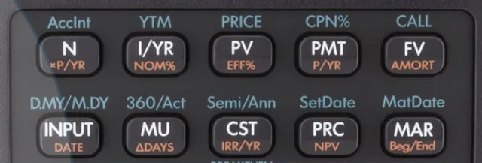
TVM

Photo credit of HP10BII+, credit hp.com

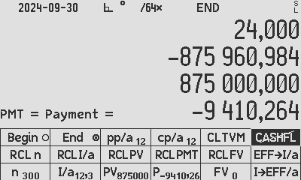

C47 TVM Menu with typical values populated, version 00.109.02.06b5

5 Standard TVM keys:
⇒ This key refers to the number of (payment) periods
⇒ This key refers to the interest rate (10% would be 10 not 0.10). a.k.a. discount rate or rate of return.
⇒ This key refers to the Present Value
⇒ This key refers to the Annuity Payment
⇒ This key refers to the Future Value

Special options:
Payment periods per year, generally 1 or 12.
Compounding periods per year, generally 1 or 12.
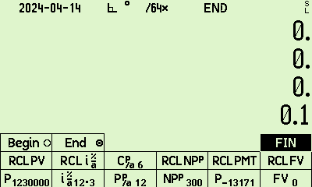 Interest on the beginning of the period, or end of the period.

Section 2: Worked out tutorial Drs. Baker & Lin

From the great tutorial by Dr. Kevin Bracker; Dr. Fang Lin; and jpursley at Pressbooks or Wayback Machine:
All references below coloured in yellow are directly taken from linked document, under the appropriate Creative Commons license NC4.0 by in this referenced document.

Example One:
6  7  10 000  0  Here, on C47 you have to specify the details of compounding. Do 1 and will be defaulted to the same. Ensure End is set:.  is -15 007.30 | 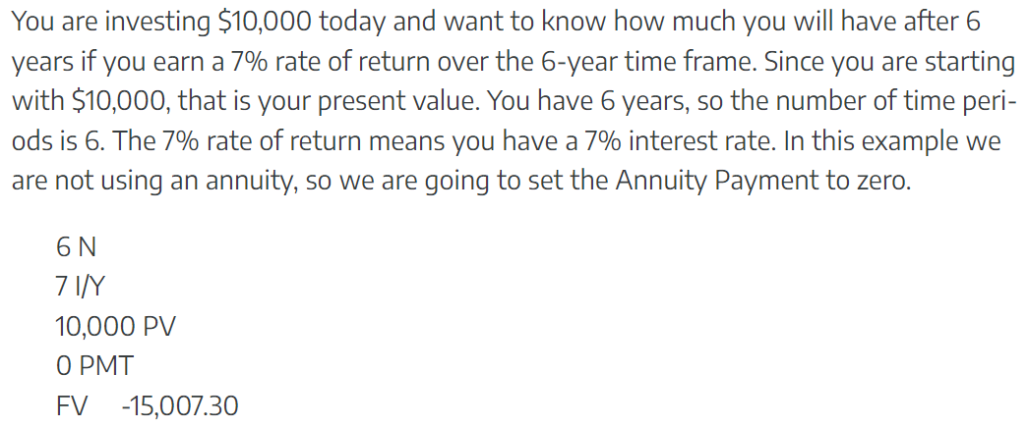

Example Two:
5  9  0  6 000  Here, on C47 you have to specify the details of compounding. Do 1 and will be defaulted to the same. Ensure End is set:.  is -3 899.59 | 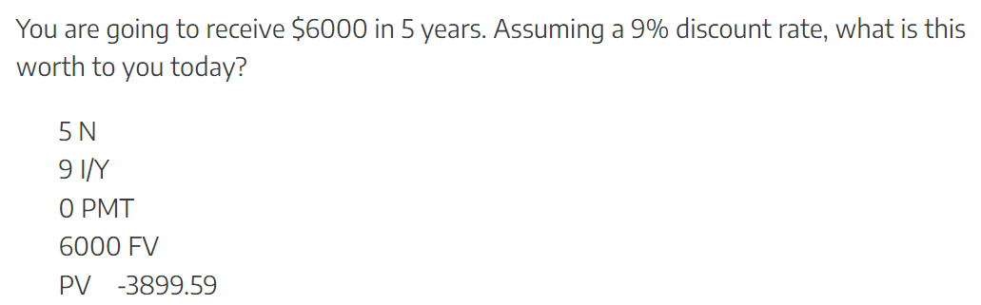
Note: light grey represents settings the same as the previous problem, i.e. no need to re-enter those.

Example Three:
25  6  400 000  0  Here, on C47 you have to specify the details of compounding. Do 1 and will be defaulted to the same. Ensure End is set:.  is -5 113 342.46 | 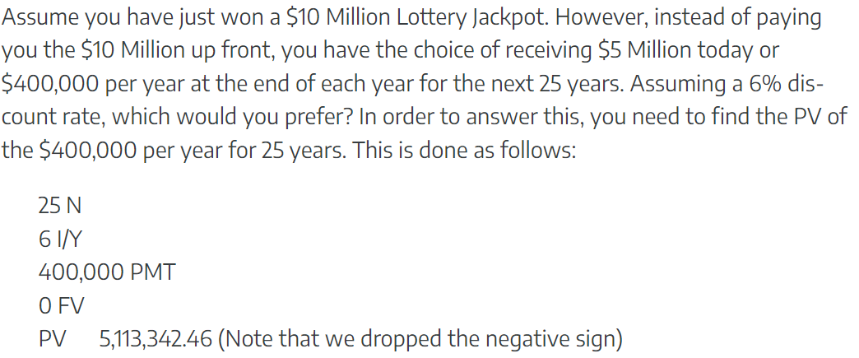  Our understanding is that the lure is 0.4M x 25 = 10M, vs. the single payment of half of that, but right now.  To get back to the original question, receiving the $10M in total over 25 years is clearly better than receiving $5M now!
Note: light grey represents settings the same as the previous problem, i.e. no need to re-enter those.

Example Three A:
All the same as Ex 3, set to BEGIN:  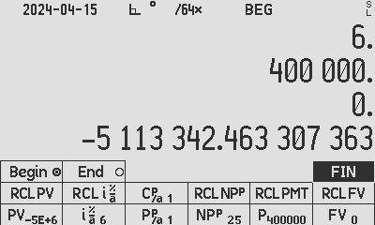  is -5 420 143.01 | To be more realistic, as the first 400k will be paid immediately, set to Begin, and see the ‘deal’ being worth even more making it the right decision to take the deal.

Example Three B & C: calculating using future end values
C47 Solution B:  25  6  5 000 000  0  1 .  is -21 459 353.60 | Although the original solution THREE A (in yellow above) is the most elegant, a more “hand-waiving” intuitive way (as opposed to the quickest way) to illustrate the compounding comparison better, is equally easily done on the C47:  We simply compare the tangible future values of both deals instead of the ‘financial’ way of evaluating the current worth of a future investment: Clearly the same answer, that $23.3M is more convincing than $21.5M:
C47 Solution C:  25  6  0  400 000  1 .  is -23 262 553.09 | B: We first check what $5M would do for us in 25 years:  25 N  6 I/Y  5 000 000 PV  0 PMT  FV $21,459,353.60 (dropped the negative sign) | C: Then what the “deal” would do for us in the same 25 years:  25 N  6 I/Y  0 PV  400 000 PMT  FV $23,262,553.09 (dropped the negative sign)

Example Four:
20  10  0  1 000 000  Here, on C47 you have to specify the details of compounding. Do 1 and will be defaulted to the same. Ensure End is set:.  is -17 459.62 | 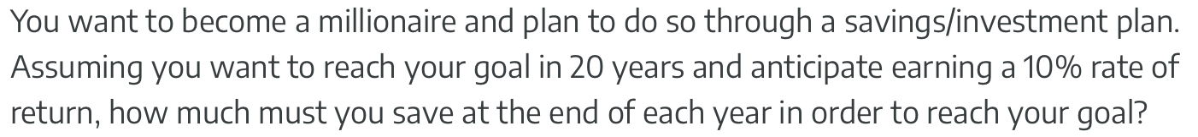  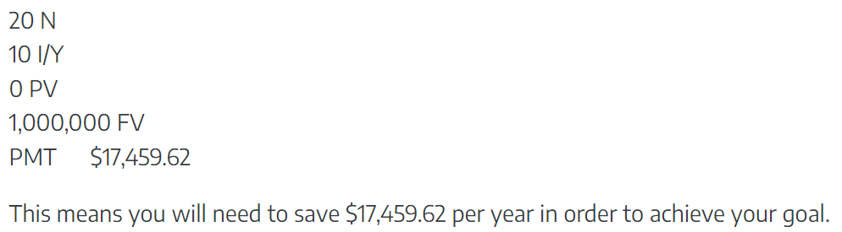
Note: light grey represents settings the same as the previous problem, i.e. no need to re-enter those.

Example Five:
C47 has the setting Payment Periods Per Year, so type 26 and it is assumed the Compounding Periods Per Year is the same.  30 ENTER 26 X  10 (still the same as Ex 4)  0 (still the same as Ex 4)  1 000 000 (still the same as Ex 4)  Ensure End is set:  (still the same as Ex 4).  is -202.75 | 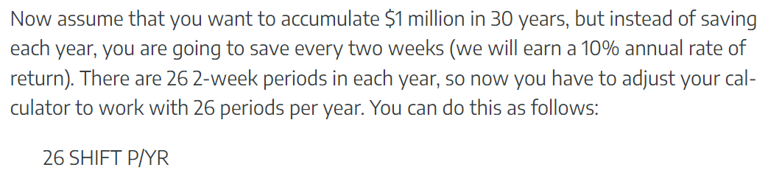  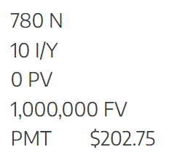
Note: light grey represents settings the same as the previous problem, i.e. no need to re-enter those.

Example Six:
C47 has the setting Payment Periods Per Year, so type 1 and it is assumed the Compounding Periods Per Year is the same. (still the same as Ex 4, 5)  35  -3 000  0 (still the same form Ex 4, 5)  1 000 000 (still the same form Ex 4, 5)  Ensure End is set:  (still the same as Ex 4, 5).  is 10.89 % | 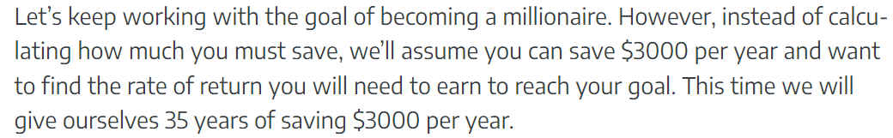  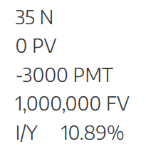
Note: light grey represents settings the same as the previous problem, i.e. no need to re-enter those.

Example Seven:
C47 has the setting Payment Periods Per Year, so type 1 and it is assumed the Compounding Periods Per Year is the same. (still the same as Ex 4, 5, 6)  35 (still the same as Ex 6)  -3 000 (still the same as Ex 6)  -40 000  1 000 000 (still the same as Ex 4, 5, 6)  Ensure End is set:  (still the same as Ex 4, 5, 6).  is 7.63 % | 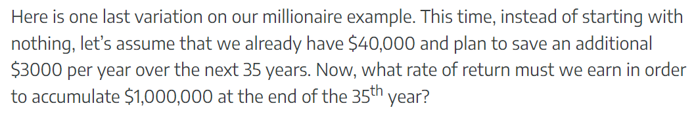  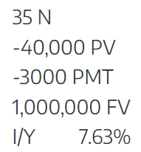
Note: light grey represents settings the same as the previous problem, i.e. no need to re-enter those.

Examples Eight through Ten are “Cash Flow Problems” cannot yet be done by C47:
Example Eleven:
C47 does have EFF% from the latest version 00.109.02.00.

7.8 to enter NOM% or Nominal interest value  4 for 4 compounding periods per year.  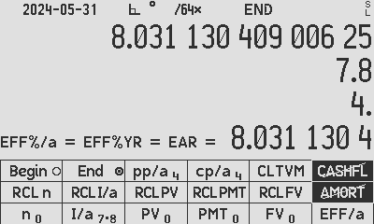 is 8.0311 %  (Or press 4 for 4 Payment Periods Per Year, which does not matter, but will always follow.) | 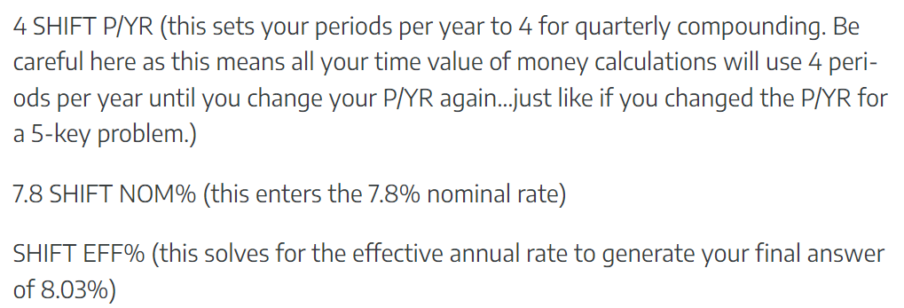
7.6 to enter NOM% or Nominal interest value  365 for 365 Periods Per Year.   is 7.8954% | 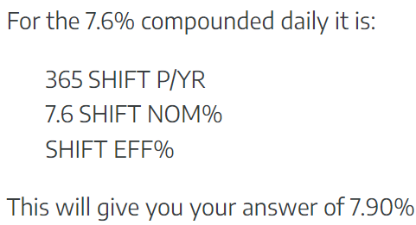

Section 3: From Swissmicros Forum, dm319’s problem set

From the post of DM319 https://forum.swissmicros.com/viewtopic.php?f=2&t=3987, relating to comparative tests for TVM on multiple calculators. Here, the problem solutions are handled for C47 interest only as part of the application note for illustrating the compilation of RPN TVN programs on C47. Do follow the linked reference for updated results on all tested calculators:
| # | Ref | N | I%YR | PV | PMT | FV | P/YR | Mode |
|----|------------|--------------|-----------|----------|--------------|-----------|------|-------|
| 1 | DM | 38 x 12 | 5.25% | 270'000 | ? | 0 | 12 | end |
| 1b | DM | 38 x 12 | ? | 270'000 | -14'584/12 | 0 | 12 | end |
| 2 | SlideRule | 360 | 15% → 12% | 100'000 | ?-? | 0 | 12 | end |
|----|------------|--------------|-----------|----------|--------------|-----------|------|-------|
https://www.hpmuseum.org/forum/thread-20707.html. Calculate PMT, given n = 360, I%YR = 15%, PV = 100000, FV = 0, then calculate PMT again with I%YR = 12%. Subtract the two results, and put that back into PMT, then change n = 36 and I%YR = 15% again, and calculate PV.

|----|------------|--------------|-----------|----------|--------------|-----------|------|-------|
| 3 | Kahan 1983 | 60x60x24x365 | 10% | 0 | -0.01 | ? | =N | end |
|----|------------|--------------|-----------|----------|--------------|-----------|------|-------|
https://www.hpmuseum.org/forum/thread-1012.html

|----|------------|--------------|-----------|----------|--------------|-----------|------|-------|
| 4 | DM | 480 | 0 → ? | 100'000 | ?→ PMT | 0 | 12 | end |
|----|------------|--------------|-----------|----------|--------------|-----------|------|-------|
Calculate PMT first given I%YR = 0, then re-input this back into PMT and calculate I%YR. On the HP-12c this is best done by pressing x<>y twice before putting back into PMT. On C47 this is not required as the last solved value remains in the I/a register.

|----|------------|--------------|-----------|----------|--------------|-----------|------|-------|
| 5 | Dieter | 10 | ? | 50 | -30 | 400 | 1 | end |
| 6 | Dieter | 10 | ? | 50 | -30 | 80 | 1 | end |
|----|------------|--------------|-----------|----------|--------------|-----------|------|-------|
https://www.hpmuseum.org/cgi-sys/cgiwrap/hpmuseum/archv021.cgi?read=234439. Note that both these problems have more than one solution.

|----|------------|--------------|-----------|----------|--------------|-----------|------|-------|
| 7 | A Chan | 10 | ? | -100 | 10 | 1e-10 | 12 | end |
|----|------------|--------------|-----------|----------|--------------|-----------|------|-------|
https://www.hpmuseum.org/forum/thread-18359-post-161549.html#pid161549

|----|------------|--------------|-----------|----------|--------------|-----------|------|-------|
| 8 | Miguel | 32 | ? | -999'999 | 0 | 1e6 | 1 | end |
|----|------------|--------------|-----------|----------|--------------|-----------|------|-------|
https://www.hpmuseum.org/cgi-sys/cgiwrap/hpmuseum/archv017.cgi?read=120592

|----|------------|--------------|-----------|----------|--------------|-----------|------|-------|
| 9 | DM | ? | 25 | 100000 | -2083.333334 | 0 | 12 | end |
| 10 | DM | ? | 25 | 100000 | -2040.816327 | 0 | 12 | begin |
|----|------------|--------------|-----------|----------|--------------|-----------|------|-------|
|----|------------|--------------|-----------|----------|--------------|-----------|------|-------|
| 11 | robve | 60x24x365 | 1/6% → ? | 0 | -0.01 | ?→ FV | =N | end |
| 12 | robve | 40 | ? → I%YR | 900 | -400 | -1000 → ? | 1 | begin |
|----|------------|--------------|-----------|----------|--------------|-----------|------|-------|
https://www.hpmuseum.org/forum/thread-16565-page-2.html Calculate for FV first, re-input back to FV and compute I%YR. 12: Calculate for i first, re-input back into i and compute FV.

- Table copied from quoted link, modified typographically, 2024-09-30.

- Added text in brown.

Result of Pall program: stored file:
 | Problem 1 | Problem 1b | Problem 2
1-5 | -1368.14835535057757212882816319868 | 4.373218372310086835354687826497751 | 6803.092161985597113625555764464724
 | Problem 3 | Problem 4
1 | 331667.0066907768917803419084360507 | ERR
2-5 | 331667.0066907768917803419084360507 | - 3.75935122288958926199999999999999E-19
 | Problem 5 | Problem 5A | Problem 5B
1 | ERR | N/A | 53.17221326838472431046024137437116
2 | 14.43587132807995697420470129887705 | 14.43587132807995697420470129887705 | 53.17221326838472431046024137437116
3-5 | 14.43587132807995697420470129887705 | I’m not sure how and why this is done | 53.17221326838472431046024137437116
 | Problem 6 | Problem 6A (I called this B at the time) | Problem 6B
1 | 58.46195526622098709870320744645958 | 58.46195526622098709870320744645958 | ERR
2 | -36.89336987417774420723991401135426 | 58.46195526622098709870320744645958 | -36.89336987417774420723991401135426
3-5 | -36.89336987417774420723991401135426 | 58.46195526622098709870320744645958 | I’m not sure how and why this is done
 | Problem 7 | Problem 8
1 | 2.181818181815806921160850718651876e-10 | 3.125001611329216004244745444268473e-6
2-5 | 2.18181818181580062818816748324244E-10 | 3.125001611329216004244745444268481e-6
 | Problem 9 | Problem 10
1-2 | 1060.303390000510007127328529884813 | 1076.319544367706646435106131044217
3-4 | 1060.303390000510007127328529884813 | 1076.319544367706646435106131044440
5 | 1060.303390000510007127328529884813 | 1076.31954436770664643510613104444
 | Problem 11 | Problem 12
1 | N/A | N/A
2-5 | 0.1666666666666666666666666664703976 | -999.9999999999999999999999999999993

- C47 1531f1cb2 00.109.02.00xx 2024-05-23
- C47 eadc4507f 00.109.02.00xx 2024-06-02
- C47 dec8c3e 00.109.02.06b5 2024-09-30
- C47 256756e 00.109.02.07b5 2025-04-22
- R47 b3002aa 00.109.03.00b2. 2026-02-05

These problems were solved using RPN programs, illustrating the use thereof on C47: All programs can be downloaded from https://47calc.com, directly linked here:
Dm319 Problem 1:  0001: LBL 'P1'  0002: 38  0003: 12  0004: *  0005: STO 'NPPER'  0006: 5.25  0007: STO 'I%/a'  0008: 270 000  0009: STO 'PV'  0010: 0  0011: STO 'PMT'  0012: 0  0013: STO 'FV'  0014: 12  0015: STO 'PPER/a'  0016: STO 'CPER/a'  0017: ENDP  0018: PMT  0019: END  Result in 0.6 sec, USB powered C47 on DM42:  PMT = -1368.14835535057757212882816319868 | Dm319 Problem 1b:  0001: LBL 'P1b'  0002: 38  0003: 12  0004: *  0005: STO 'NPPER'  0006: 0  0007: STO 'I%/a'  0008: 270 000  0009: STO 'PV'  0010: -14 584  0011: 12  0012: /  0013: STO 'PMT'  0014: 0  0015: STO 'FV'  0016: 12  0017: STO 'PPER/a'  0018: STO 'CPER/a'  0019: ENDP  0020: I/a  0021: END  Result in 0.5 sec, USB powered C47 on DM42:  I/a = 4.373218372310086835354687826497751 %
Dm319 Problem 2:  0001: LBL 'P2'  0002: 360  0003: STO 'NPPER'  0004: 15  0005: STO 'I%/a'  0006: 100 000  0007: STO 'PV'  0008: 0  0009: STO 'FV'  0010: 12  0011: STO 'PPER/a'  0012: STO 'CPER/a'  0013: ENDP  0014: 0  0015: STO 'PMT'  0016: PMT  0017: 12  0018: STO 'I%/a'  0019: DROPX  0020: PMT  0021: -  0022: STO 'PMT'  0023: 36  0024: STO 'NPPER'  0025: 15  0026: STO 'I%/a'  0027: PV  0028: END  Result in 1.2 sec, USB powered C47 on DM42:  PV = 6803.092161985597113625555764464724 | Dm319 Problem 3:  0001: LBL 'P3'  0002: 60  0003: X^2  0004: 24  0005: *  0006: 365  0007: *  0008: STO 'NPPER'  0009: STO 'PPER/a'  0010: STO 'CPER/a'  0011: 10  0012: STO 'I%/a'  0013: 0  0014: STO 'PV'  0015: -0.01  0016: STO 'PMT'  0017: ENDP  0018: FV  0019: END  Result in 1.0 sec, USB powered C47 on DM42:  FV = 331667.0066907768917803419084360507

Dm319 Problem 4:

0001: LBL 'P4'
0002: 480
0003: STO 'NPPER'
0004: 0
0005: STO 'I%/a'
0006: 100 000
0007: STO 'PV'
0008: 0
0009: STO 'PMT'
0010: STO 'FV'
0011: 12
0012: STO 'PPER/a'
0013: STO 'CPER/a'
0014: ENDP
0015: PMT
0016: I/a
0017: END

Result in 1.2 sec, USB powered C47 on DM42:
I/a = -3.75935122288958926199999999999999E-19 %

Dm319 Problem 5: First solution  Default result, without biasing the solver.  0001: LBL 'P5'  0002: 10  0003: STO 'NPPER'  0004: 0  0005: STO 'I%/a'  0006: 50  0007: STO 'PV'  0008: -30  0009: STO 'PMT'  0010: 400  0011: STO 'FV'  0012: 1  0013: STO 'PPER/a'  0014: STO 'CPER/a'  0015: ENDP  0016: I/a  0017: END  Result in 0.5 sec, USB powered C47 on DM42:  I/a = 14.43587132807995697420470129887705 % | Dm319 Problem 5: Second solution  The key to the second solution is to point the solver to closer to the expected second result, i.e. store 50 in I%/a to make it search starting at 50. See brown:  0001: LBL 'P5b'  0002: 10  0003: STO 'NPPER'  0004: 0  0005: STO 'I%/a'  0006: 50  0007: STO 'PV'  0008: -30  0009: STO 'PMT'  0010: 400  0011: STO 'FV'  0012: 1  0013: STO 'PPER/a'  0014: STO 'CPER/a'  0015: ENDP  0016: 50  0017: STO 'I%/a'  0018: DROPX  0019: I/a  0020: END  Result in 0.5 sec, USB powered C47 on DM42:  I/a = 53.17221326838472431046024137437116 %
Dm319 Problem 6: First solution  Default result, without biasing the solver.  0001: LBL 'P6'  0002: 10  0003: STO 'NPPER'  0004: 0  0005: STO 'I%/a'  0006: 50  0007: STO 'PV'  0008: -30  0009: STO 'PMT'  0010: 80  0011: STO 'FV'  0012: 1  0013: STO 'PPER/a'  0014: STO 'CPER/a'  0015: ENDP  0016: I/a  0017: END  Result in 0.4 sec, USB powered C47 on DM42:  I/a = -36.89336987417774420723991401135426 % | Dm319 Problem 6: Second solution  The key to the second solution is to point the solver to closer to the expected second result, i.e. store 50 in I%/a to make it search starting at 50. See brown:  0001: LBL 'P6b'  0002: 10  0003: STO 'NPPER'  0004: 0  0005: STO 'I%/a'  0006: 50  0007: STO 'PV'  0008: -30  0009: STO 'PMT'  0010: 80  0011: STO 'FV'  0012: 1  0013: STO 'PPER/a'  0014: STO 'CPER/a'  0015: ENDP  0016: 50  0017: STO 'I%/a'  0018: DROPX  0019: I/a  0020: END  Result in 0.7 sec, USB powered C47 on DM42:  I/a = 58.46195526622098709870320744645958 %

Dm319 Problem 7:  0001: LBL 'P7'  0002: 10  0003: STO 'NPPER'  0004: 0  0005: STO 'I%/a'  0006: -100  0007: STO 'PV'  0008: 10  0009: STO 'PMT'  0010: 1.*10^-10  0011: STO 'FV'  0012: 12  0013: STO 'PPER/a'  0014: STO 'CPER/a'  0015: ENDP  0016: I/a  0017: END  Result in 0.7 sec, USB powered C47 on DM42:  I/a = 2.18181818181580062818816748324244E-10 % | Dm319 Problem 8:  0001: LBL 'P8'  0002: 32  0003: STO 'NPPER'  0004: 0  0005: STO 'I%/a'  0006: -999 999  0007: STO 'PV'  0008: 0  0009: STO 'PMT'  0010: 1.*10^6  0011: STO 'FV'  0012: 1  0013: STO 'PPER/a'  0014: STO 'CPER/a'  0015: ENDP  0016: I/a  0017: END  Result in 0.6 sec, USB powered C47 on DM42:  I/a = 0.000003125001611329216004244745444268481 %
Dm319 Problem 9:  0001: LBL 'P9'  0002: 0  0003: STO 'NPPER'  0004: 25  0005: STO 'I%/a'  0006: 100 000  0007: STO 'PV'  0008: -2 083.333 334  0009: STO 'PMT'  0010: 0  0011: STO 'FV'  0012: 12  0013: STO 'PPER/a'  0014: STO 'CPER/a'  0015: ENDP  0016: n  0017: END  Result in 4.3 sec, USB powered C47 on DM42:  n = 1060.303390000510007127328529884813 | Dm319 Problem 10:  0001: LBL 'P10'  0002: 0  0003: STO 'NPPER'  0004: 25  0005: STO 'I%/a'  0006: 100 000  0007: STO 'PV'  0008: -2 040.816 327  0009: STO 'PMT'  0010: 0  0011: STO 'FV'  0012: 12  0013: STO 'PPER/a'  0014: STO 'CPER/a'  0015: BeginP  0016: n  0017: END  Result in 3.0 sec, USB powered C47 on DM42:  n = 1076.31954436770664643510613104444

Dm319 Problem 11:  0001: LBL 'P11'  0002: REM 'Problem 11, first calculate FV then I/a'  0003: 60  0004: 24  0005: 365  0006: *  0007: *  0008: STO 'NPPER'  0009: STO 'PPER/a'  0010: STO 'CPER/a'  0011: 1  0012: 6  0013: /  0014: STO 'I%/a'  0015: 0  0016: STO 'PV'  0017: -0.01  0018: STO 'PMT'  0019: ENDP  0020: FV  0021: I/a  0022: END  Result in 1.4 sec, USB powered C47 on DM42:  n = 0.1666666666666666666666666664703976 | Dm319 Problem 12:  0001: LBL 'P12'  0002: REM 'Problem 12 first do I/a then FV'  0003: 40  0004: STO 'NPPER'  0005: 900  0006: STO 'PV'  0007: -400  0008: STO 'PMT'  0009: -1 000  0010: STO 'FV'  0011: 1  0012: STO 'PPER/a'  0013: STO 'CPER/a'  0014: BeginP  0015: I/a  0016: FV  0017: END  Result in 1.0 sec, USB powered C47 on DM42:  n = -999.9999999999999999999999999999993

Sequencing program ‘Pall’:  Run all problem files and reporting results and time durations of processing:  0001: LBL 'Pall'  0002: 0  0003: STO 01  0004: XEQ 'P1'  0005: 'TVM P1:'  0006: XEQ 'TT'  0007: XEQ 'P1b'  0008: 'TVM P1b:'  0009: XEQ 'TT'  0010: XEQ 'P2'  0011: 'TVM P2:'  0012: XEQ 'TT'  0013: XEQ 'P3'  0014: 'TVM P3:'  0015: XEQ 'TT'  0016: XEQ 'P4'  0017: 'TVM P4:'  0018: XEQ 'TT'  0019: XEQ 'P5'  0020: 'TVM P5:'  0021: XEQ 'TT'  0022: XEQ 'P5b'  0023: 'TVM P5B(50):'  0024: XEQ 'TT'  0025: XEQ 'P6'  0026: 'TVM P6:'  0027: XEQ 'TT'  0028: XEQ 'P6b'  0029: 'TVM P6B(50):'  0030: XEQ 'TT'  0031: XEQ 'P7'  0032: 'TVM P7:'  0033: XEQ 'TT'  0034: XEQ 'P8'  0035: 'TVM P8:'  0036: XEQ 'TT'  0037: XEQ 'P9'  0038: 'TVM P9:'  0039: XEQ 'TT'  0040: XEQ 'P10'  0041: 'TVM P10:'  0042: XEQ 'TT'  0043: XEQ 'P11'  0044: 'TVM P11:'  0045: XEQ 'TT'  0046: XEQ 'P12'  0047: 'TVM P12:'  0048: XEQ 'TT'  0049: END | Subroutine ‘TT’:  Print results to text files:  0001: LBL 'TT'  0002: LASTT  0003: STO 00  0004: DROPX  0005: Printxy  0006: RCL 00  0007: RCL 01  0008: -  0009: 10.0  0010: /  0011: ' Sec'  0012: SIG 02  0013: +  0014: Printx  0015: RCL 00  0016: STO 01  0017: END

Original 012: 2024-06-01, on C47 version 00.109.02.00
Updated 012a: 2025-04-22, on C47 version 00.109.00.07b5
Updated 012b: 2026-02-05, on C47/R47 version 00.109.03.00

Author Jaco Mostert; Proofread by Duncan Murray
Copyright (C) 206 The C47 Development Team. Permission is granted to copy, distribute and/or modify this document under the terms of the GNU Free Documentation License, Version 1.3 or any later version published by the Free Software Foundation; with no Invariant Sections, no Front-Cover Texts, and no Back-Cover Texts. A copy of the license can be downloaded from gnu.org.
Quoted yellow portions copyright to CC NC4.0 license as stated in referenced document.

